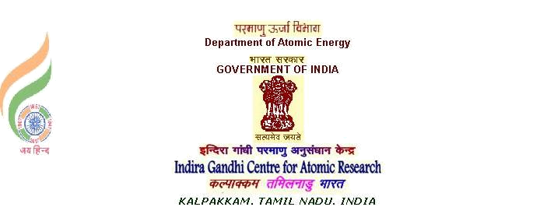

Sanga Ramesh | Phone : 044 27480500 -22969
SCIENTIFIC OFFICER ‘E | email : stram@igcar.gov.in
EIG, IGCAR
KALPAKKAM, KANCHIPURAM Dt,
TAMILNADU - 603102.

INTERNSHIP CERTIFICATE

I certify that that Ms. M.M.SHRIVIDHATRI (Roll no. 2019113006 ), second year CND student of IIIT, Hyderabad, has completed internship on “Sensor parameter survey among the imported bio medical instrumentation towards development of indigenous equivalents" in IGCAR, DAE, during the month of December 2020, under my guidance.

During this period, her performance and conduct are satisfactory.

(Sanga Ramesh)
14/01/2021

